Assignment 4

* Create a HTML Form as shown below

ChangePassword.html

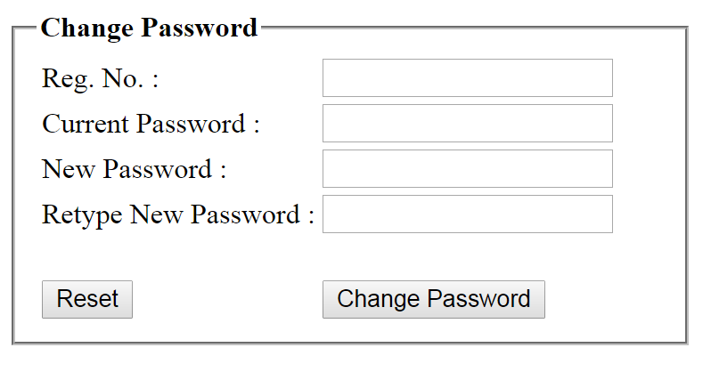

* Create Servelt by name ChangePasswordServlet, which gets the request from this form,

1. Get the Form Data
2. Check "New Password" & "Retype New Password" are matching. If NO, then display Error Message in the Browser
3. If YES, then check "New Password" & “Current Password" are matching. If NO, then display Error Message in the Browser
4. If YES, then check Reg. No. & Current Password are valid by interacting with BECM6_DB Database
5. If In-Valid, then display "**Invalid Reg. No. & Current Password**" Error Message in the Browser
6. If Valid, update the "Current Password" with "New Password" and Print Success Message in the Browser